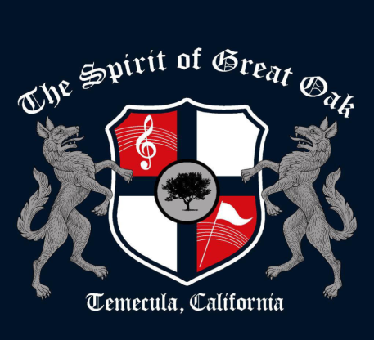

BANNER ADVERTISING

Dear Fans and Supporters of The Spirit of Great Oak Band and Guard,

I am writing you on behalf of the student-musicians who attend our Great Oak High School. It has become increasingly difficult to secure funding for music programs and as we head into the 2014-2015 year, we are in need of your support. As you are aware, over the past several years we have seen educational budgets slashed leaving little money for extra-curricular activities like Marching Band and Color Guard, Winter Drumline and Color Guard and our many other instrumental programs in our public schools.

Our Band Booster Group is responsible for raising funds to ensure that all our musicians and color guard members at GOHS have the money and resources necessary to offer quality programs each year. The financial burden continues to rise as we search for the means to pay for equipment, uniforms, competitions, transportation, coaches, and many other expenses.

This fundraising is done in several ways: major events (Competitions, Restaurant Nights, SCRIP, Christmas Tree Sales, and Spirit Run for the Arts), concessions, band spirit wear, and banners. We are asking that you partner with us in our fundraising efforts this year. All the money raised from banner advertising goes towards the operating expenses of the Spirit of Great Oak so that our musicians and guard members enjoy a first class experience. Please consider purchasing a durable 5’ X 7’ outdoor banner, with your business name and/or logo. Banners are displayed in the location of your choice, which include the football stadium, softball field, or both for one calendar year.

To be a sponsor of The Spirit of Great Oak Band and Guard while also gaining an opportunity to promote your business, please complete the attached Banner Order Form, and mail or bring to Great Oak High School (attn. Band). Banner donations to The Spirit of Great Oak Band and Guard are received by Great Oak Academic Leadership Society (GOALS), a 501(c)(3) nonprofit corporation possibly making your donation tax deductible. Please check with your tax adviser.

Thank you for your consideration.

Sincerely,
Tricia Graff
President/Spirit of Great Oak Band Booster Group

